

**Session : 2023 – 2024**

HOTEL MANAGEMENT WEBSITE

**A PROJECT REPORT**

**Submitted By**

Muskan Vishwakarma ( 2115000641)

Priya Rajpoot ( 2115000767 )

Rashmi Chaudhary ( 2115000832 )

***partial fulfillment for the award of the degree of***

##### BACHELOR OF ENGINEERING

**IN**

Computer Engineering & Applications

( Institute of Engineering & Technology )

**GLA University, Mathura - 281406**

## BONAFIDE CERTIFICATE

This is to certify that the project entitled “**Hotel Management Website**”, carried out as Mini Project - I, is the bonafide work of “**Muskan Vishwakarma, Priya Rajpoot, Rashmi Chaudhary**” who carried out the project work under my supervision.

##### SIGNATURE SIGNATURE

Dr. Rohit Agrawal Mr. Ankit Arora

**HEAD OF THE DEPARTMENT SUPERVISOR**

Department of Computer Engineering Technical Trainer & Application (GLAU) (GLAU)

## ACKNOWLEDGEMENT

We would like to express our deep sense of gratitude and respect towards **Mr. Ankit Arora**, Technical Trainer, Computer Science & Engineering Department for guiding and encouraging us throughout the project.

His sincerity and determination has been a constant source of inspiration for us. We also believe that he will empower us with all his great innovative ideas and different stages of the project. We would not like to miss the opportunity to thank and acknowledge the contribution of all the faculty members of the department for their kind guidance and co-operation.

##### Muskan Vishwakarma ( 2115000641 ) Priya Rajpoot ( 2115000747 )

##### Rashmi Chaudhary ( 2115000832 )

**Abstract**

## TABLE OF CONTENTS

**Abbreviations**

**Chapter 1. Introduction**

* 1. Overview
  2. Background Study
  3. Project Planning
  4. Timeline
  5. Organization of Report

**Chapter 2. Goals and Objectives**

* 1. Problem Statement
  2. Goals and Objective

**Chapter 3. Design Flow**

* 1. Hardware & Software Requirements
  2. Project Design

**Chapter 4. Technologies**

**Chapter 5. Conclusion Chapter 6. Future Work**

**References**

## ABSTRACT

The hospitality industry is undergoing a transformative evolution with the introduction of a groundbreaking Hotel Management Website. This platform is meticulously crafted to redefine the way hotels operate and cater to guests, integrating cutting-edge technologies to enhance efficiency, boost revenue, and elevate overall guest satisfaction. The user-centric design ensures an intuitive and seamless experience for both hotel administrators and guests.

The core of this innovative website lies in its advanced reservation system, providing guests with a user-friendly interface for effortless bookings. Real-time updates on room availability and pricing contribute to a smooth booking process, eliminating the complexities often associated with reservations. The dynamic room management feature optimizes inventory and pricing strategies, mitigating the risk of overbooking while maximizing occupancy and revenue.

One of the key highlights of this Hotel Management Website is its comprehensive Guest Relationship Management (CRM) system. Hotel staff can access detailed guest profiles, preferences, and history, enabling them to deliver personalized services and targeted promotions. This not only enhances guest satisfaction but also fosters loyalty, contributing to repeat business and positive word-of-mouth marketing.

Financial transactions are streamlined through the integration of a secure payment gateway, supporting multiple payment options to accommodate diverse guest preferences. The platform prioritizes data security, implementing encryption and secure authentication measures to protect guest information and financial transactions. Mobile responsiveness further enhances accessibility, allowing users to manage bookings and operations on-the-go across various devices.

Efficient task management is facilitated through a collaborative system, enabling hotel staff to assign and track tasks related to housekeeping, maintenance, and guest requests. Real-time analytics and reporting tools empower hotel administrators with valuable insights, facilitating informed decision-making to drive continuous improvement in service quality and operational effectiveness.

In conclusion, this Hotel Management Website represents a paradigm shift in the hospitality sector, offering a holistic solution to streamline operations, enhance guest experiences, and ensure the sustained success of hotels in the digital age. By embracing the power of technology, this platform is poised to set new standards for efficiency, guest satisfaction, and profitability in the dynamic landscape of the hospitality industry

## ABREVIATIONS

|  |  |
| --- | --- |
| HTML | Hyper Text Markup Language |
| CSS | Cascading Style Sheet |
| JS | Java Script |

Chapter – 1

**Introduction**

**1.1 Overview**

Welcome to our digital gateway to hospitality excellence – an immersive Hotel Management Website designed to redefine your experience in the world of travel and accommodation. As we navigate the dynamic landscape of the hospitality industry, our commitment is to offer a seamless blend of innovation and efficiency, ensuring that your stay, whether for business or leisure, is characterized by comfort, convenience, and personalized service.

In an era where technology continues to shape and elevate our daily lives, our Hotel Management Website stands as a beacon of modernity in the hospitality sector. This platform is not just a reservation system; it's a comprehensive solution crafted to streamline operations, enhance guest satisfaction, and propel your hotel to new heights of success.

Our endeavor begins with a deep understanding of the unique challenges faced by the hospitality industry today. As we embark on this journey, we aim to address these challenges head-on, leveraging cutting-edge technologies and intuitive design to create an experience that is as seamless for hotel administrators as it is for our valued guests.

Picture a world where booking a room is a breeze, where personalized services are not just a luxury but a standard, and where operational efficiency is maximized to ensure that every aspect of your stay is precisely tailored to your needs. Our Hotel Management Website is the embodiment of this vision, offering a user-friendly interface that puts the power of choice and control at your fingertips.

At the heart of our platform is a commitment to data security and guest privacy. We understand the importance of safeguarding your information, and our robust security measures ensure that your transactions and personal details are protected throughout your digital journey with us.

As we invite you to explore our Hotel Management Website, we invite you to reimagine your expectations of hospitality. This is more than a website; it's a promise of a refined, technology-driven, and seamlessly orchestrated experience. Welcome to a new era of hospitality excellence – welcome to a stay that transcends the ordinary.

##### Project Planning

The project planning phase involves a meticulous and strategic approach to outline the goals, scope, and milestones of the Hotel Management Website development. This includes the identification of key project objectives, the definition of the project scope, the establishment of clear milestones, and the deployment of effective methodologies to ensure a systematic and organized execution. A detailed timeline is crafted to provide a roadmap for development, allowing for efficient tracking, monitoring, and management of the project throughout its lifecycle. This phase sets the foundation for a successful and well-coordinated implementation, aligning the project with its overarching goals and ensuring a streamlined path towards completion.

##### Timeline

|  |  |
| --- | --- |
| 06 Nov – 07 Nov | Requirement Specification, Built up Model |
| 08 Nov – 12 Nov | Designing of Website and User Interface |
| 13 Nov – 25 Nov | Implementation started. Started building website. |
| 26 Nov | Completed Project. Testing. User Review. |
| 27 Nov – 1 Dec | Project Presentation and Report Submission. |

**Organization of Report**

Chapter 1 gives the introduction to the project specifying the need of the project, various problems which would be solved through the project and the various tasks required to be performed for completion of the project. It also tells the timeline of various activities performed.

Chapter 2 specifies the problem statement and the goals and objectives of the project.

Chapter 3 gives details about the model and design of the project. Various constraints are also discussed here. It gives the structure of the website. It provides all the details about each section provided in the website.

Chapter 4 talks about how the design is implemented using various technologies. Chapter 5 concludes the project and gives the future scope.

**Chapter-2**

## GOALS AND OBJECTIVES

##### Problem Statement

In the current landscape of the hospitality industry, traditional management systems often struggle to cope with the dynamic demands of modern travelers, resulting in operational inefficiencies and suboptimal guest experiences. There is a pressing need for an innovative solution that seamlessly integrates advanced technologies to streamline hotel operations, enhance reservation processes, and elevate overall guest satisfaction, addressing the evolving expectations of both hotel administrators and discerning guests.

##### Goals and Objectives

**1. Optimize Operational Efficiency:** Streamline hotel management processes to enhance operational efficiency, reduce manual workload, and improve the overall workflow for administrators, ensuring a more resource-efficient operation.

**2. Elevate Guest Experience:** Prioritize the guest journey by implementing user-friendly interfaces, personalized services, and efficient reservation systems to create a seamless and enjoyable experience for guests from booking to check-out.

**3. Maximize Revenue Potential:** Implement dynamic room management and pricing strategies to optimize occupancy rates and revenue generation, ensuring a balanced and strategic approach to pricing while minimizing the risk of overbooking.

**4. Implement Robust Reservation System:** Develop and integrate a state-of-the-art reservation system that provides real-time availability updates, simplifies booking processes, and accommodates various guest preferences to encourage a higher rate of successful bookings.

**5. Enhance Guest Relationship Management (CRM):** Implement a comprehensive CRM system to gather and analyze guest data, enabling personalized interactions, targeted promotions, and the cultivation of guest loyalty, ultimately contributing to repeat business and positive word-of-mouth.

**6. Ensure Data Security and Compliance:** Prioritize the implementation of robust security measures to safeguard guest information and financial transactions, ensuring compliance with data protection regulations and establishing trust among users interacting with the platform.

**Chapter-3**

# DESIGN FLOW

* 1. **Hardware and Software Requirements**
     + JavaScript, HTML, CSS
     + VSCode
     + Version Control: GitHub
     + Processor: intel core i5
     + Minimum 4GB RAM
     + Operating System: Microsoft Windows 11

# Project Design

The website has various sections such as: -

1. Home Page
2. Sign Up and Login Page
3. Menu Page
4. Rooms Page
5. Contact Us
6. About Us
7. Privacy Policy

**Fig 1. Website Banner & Logo**

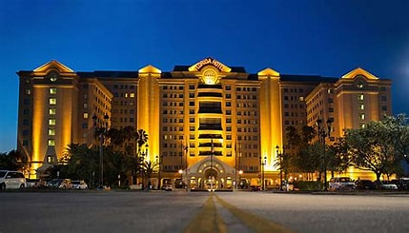

**Fig 2. Home Page**

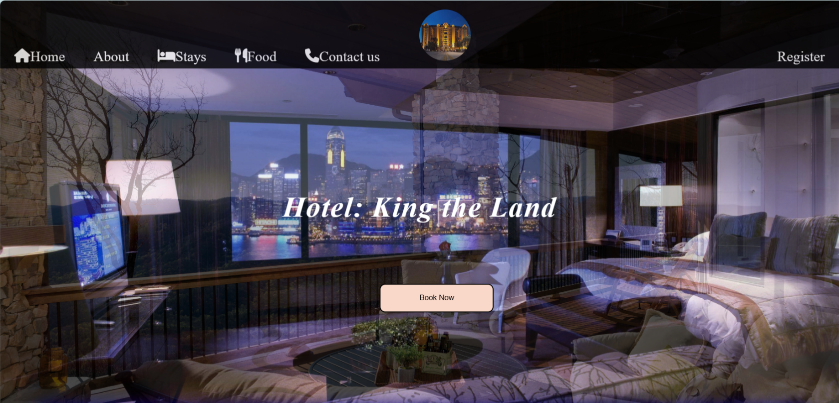

**Fig 3. Sign Up**

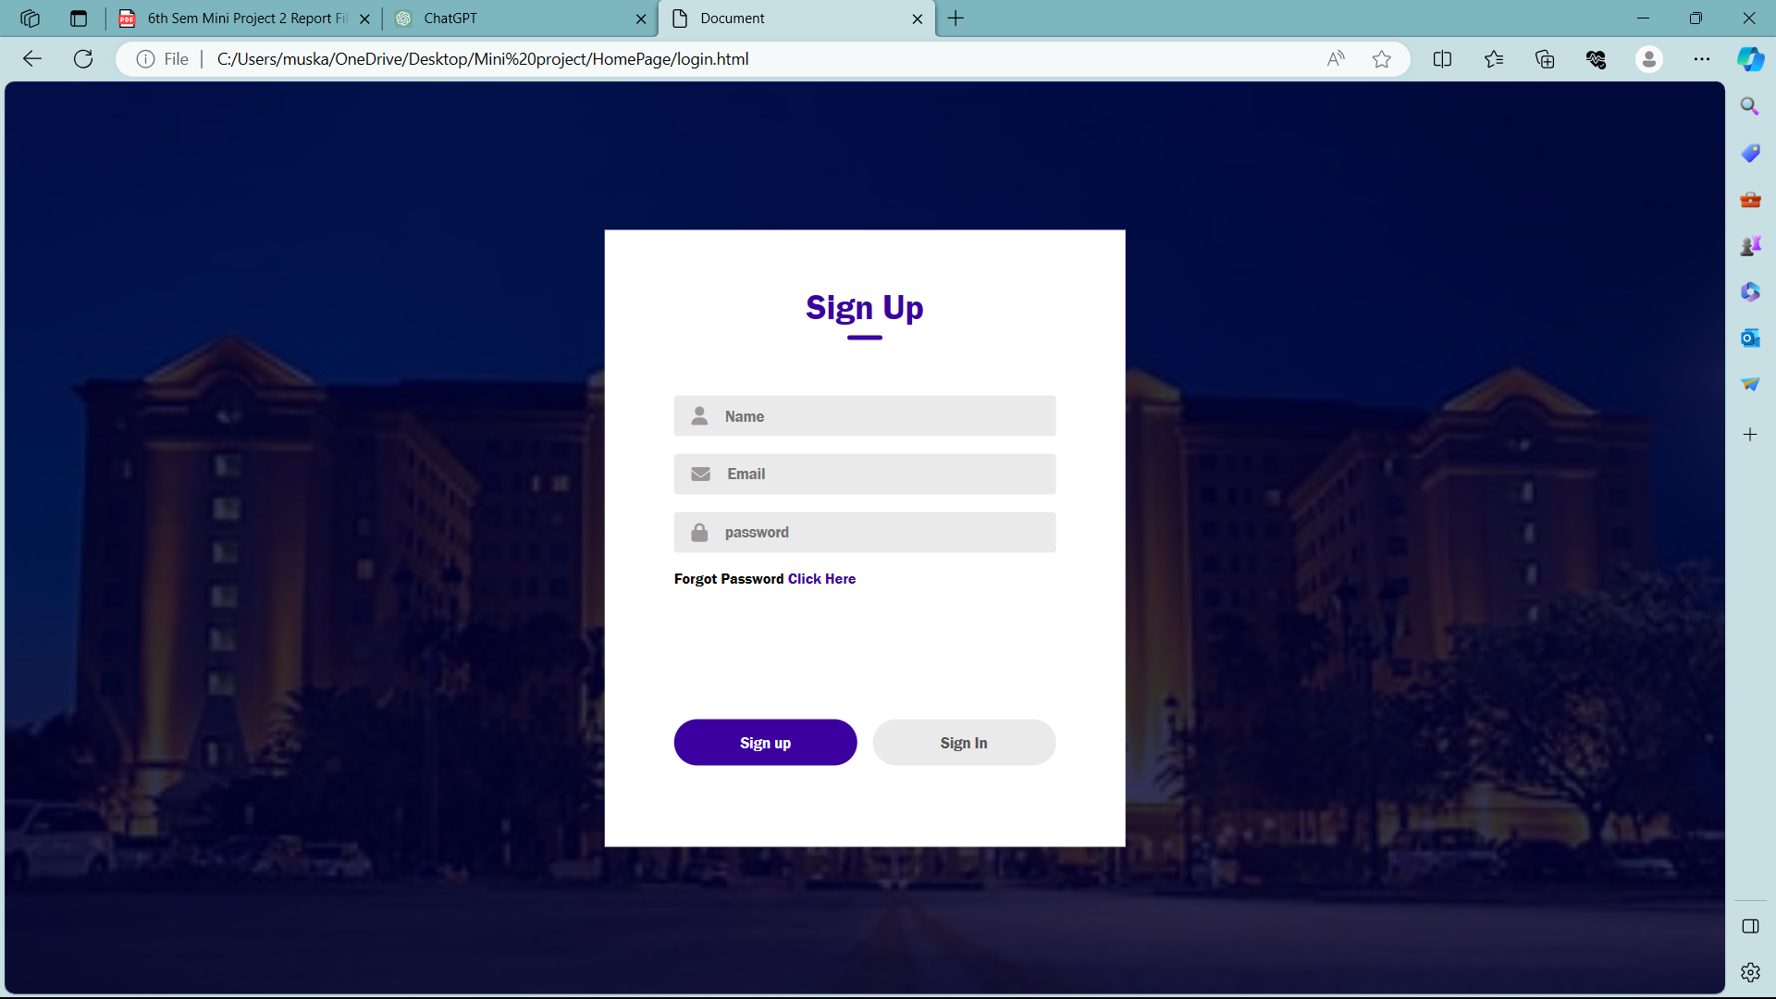

**Fig 4. About Page**

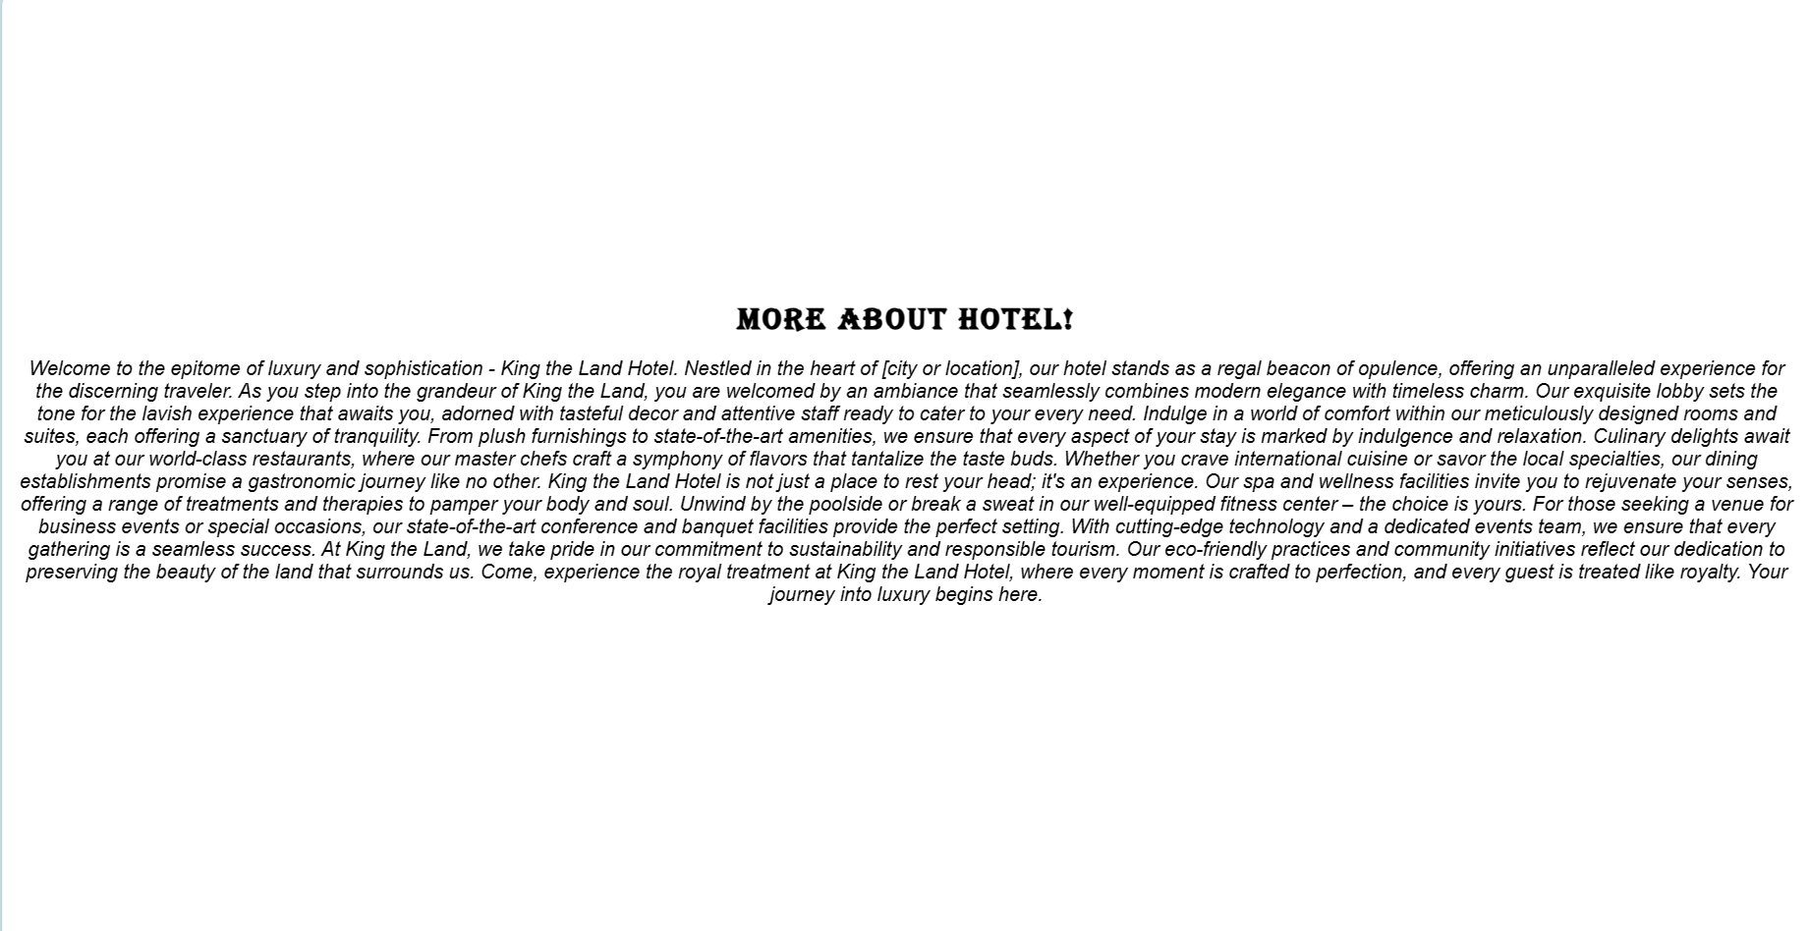

**Fig 5. Our Clients**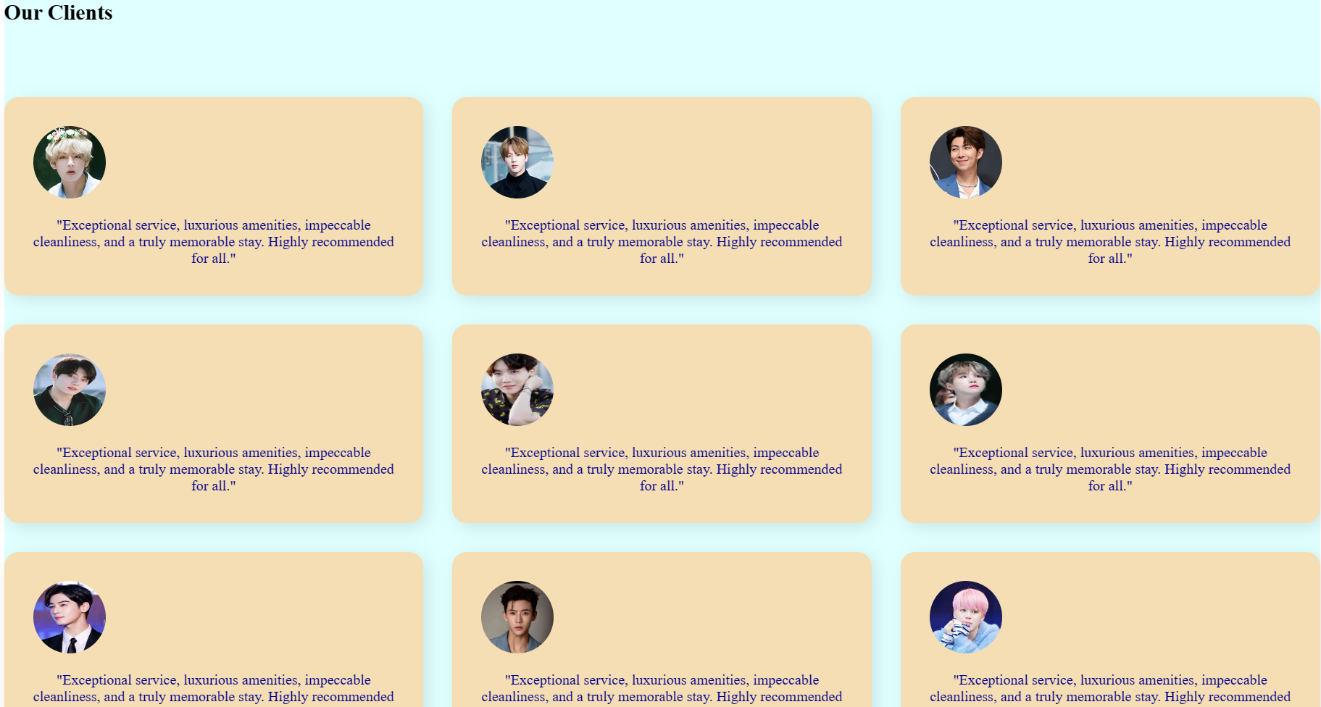

**Fig 6. Rooms homepage**

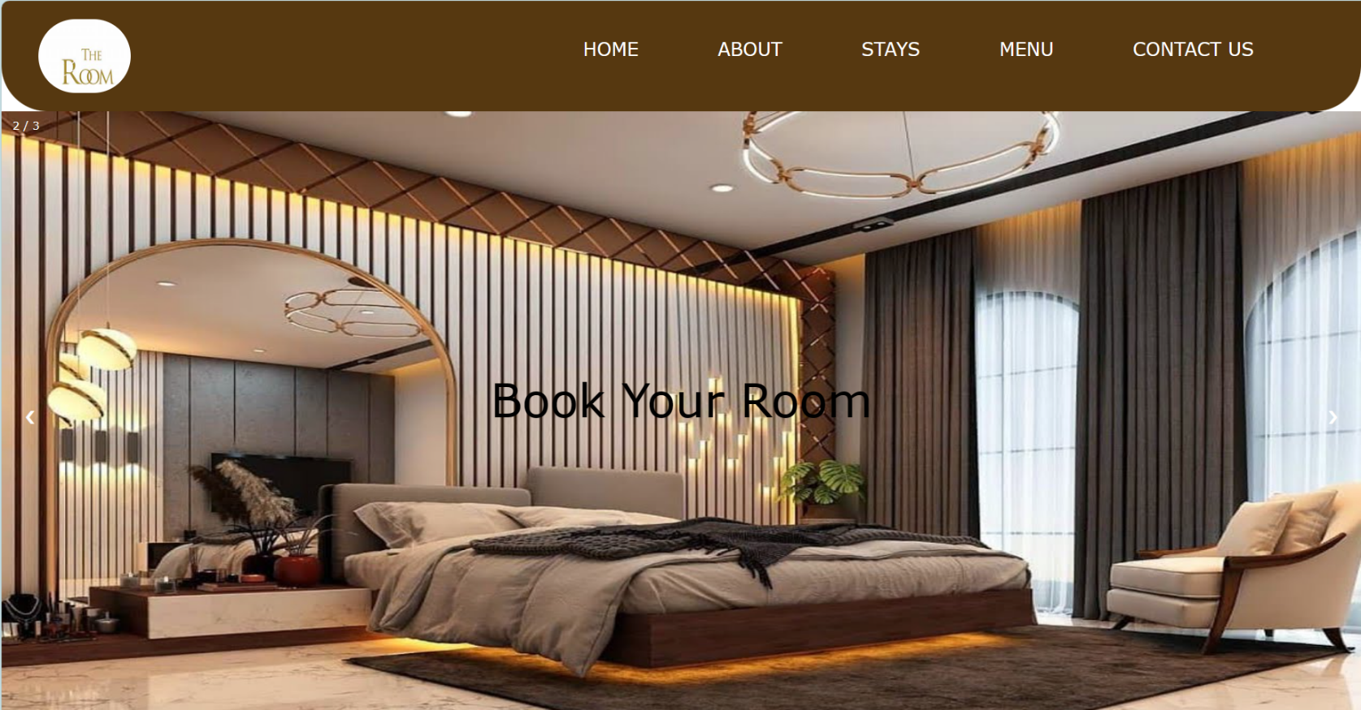

**Fig 7. Our Rooms**

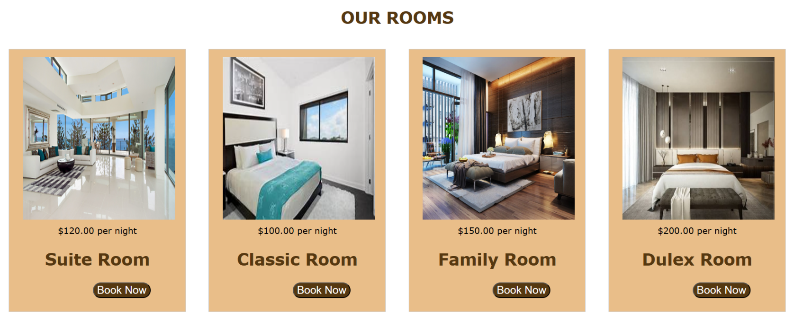

**Fig 8. Room Booking form**

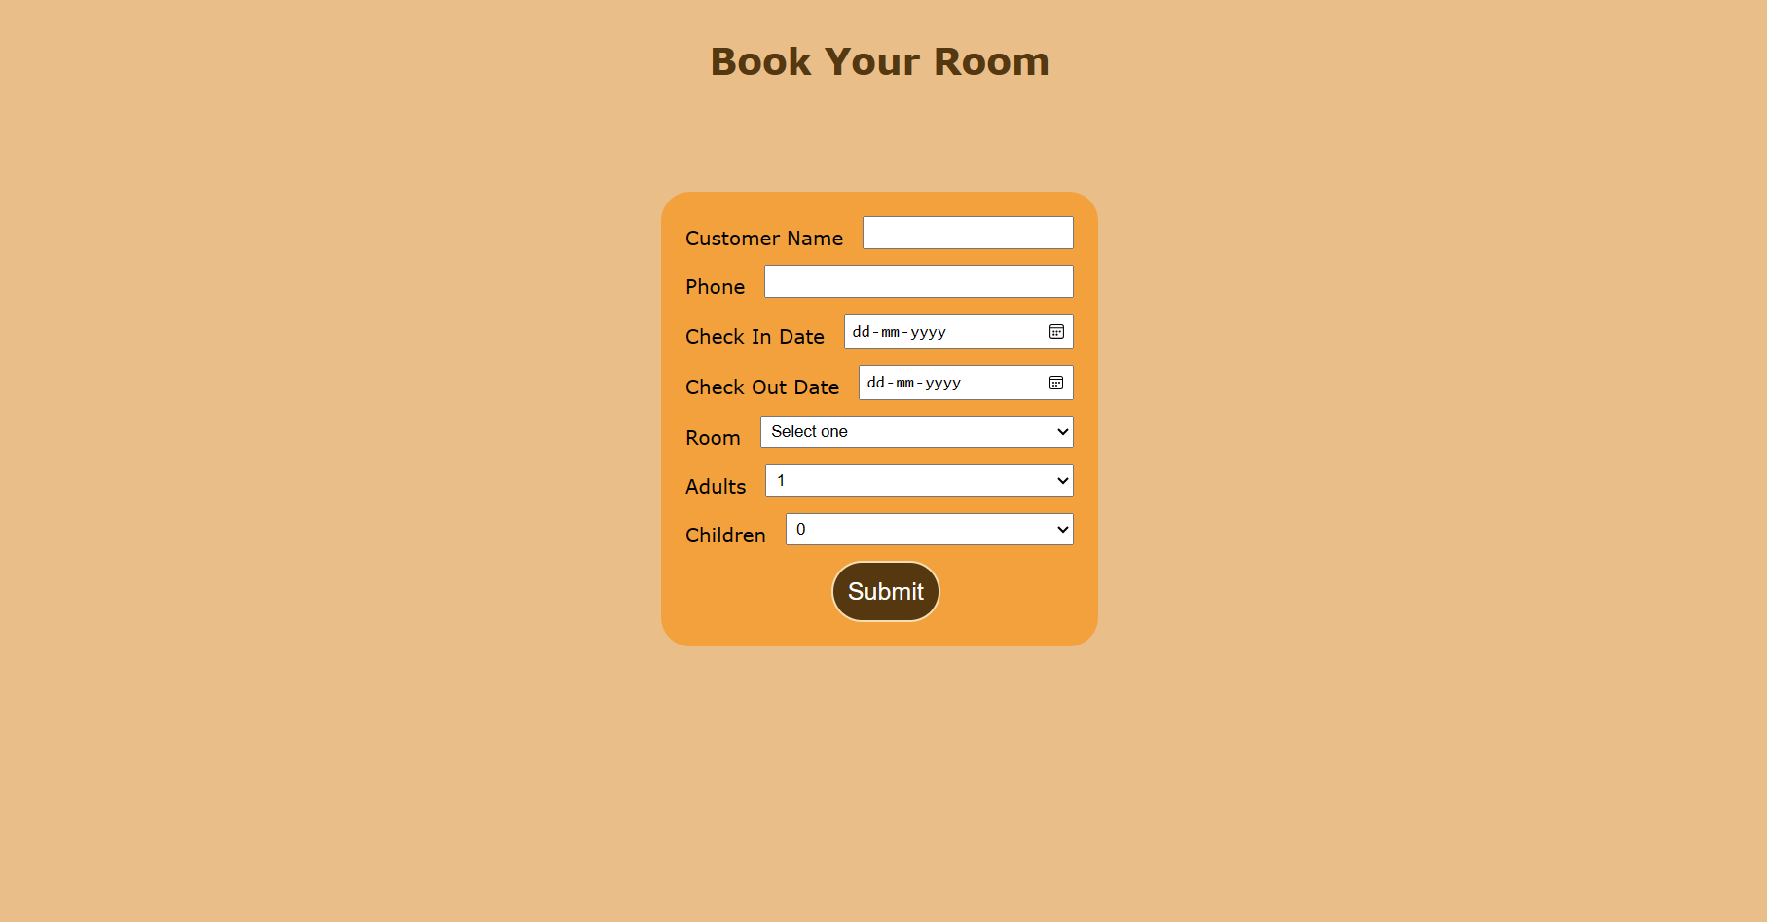

**Fig 9. Menu Homepage**

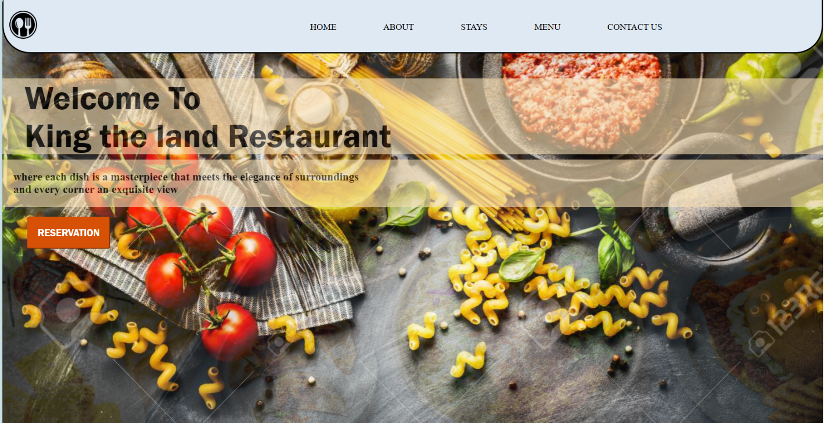

**Fig 10. Menu**

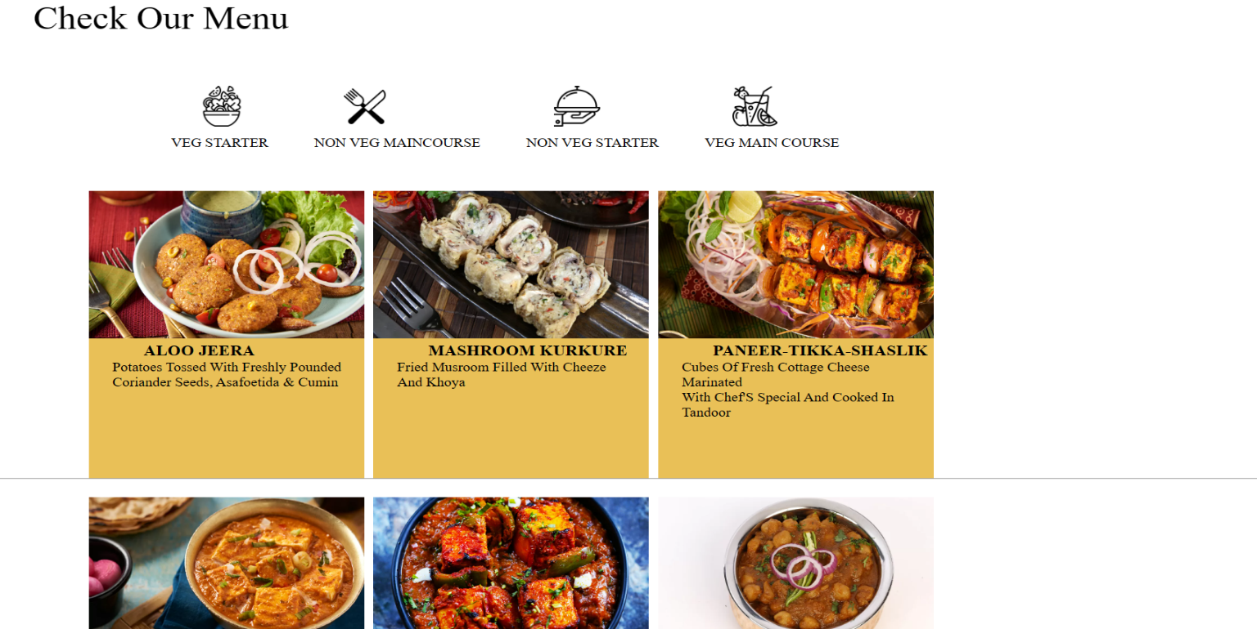

# Fig 11. Order Booking

# WhatsApp

# Fig 11. Contact Us

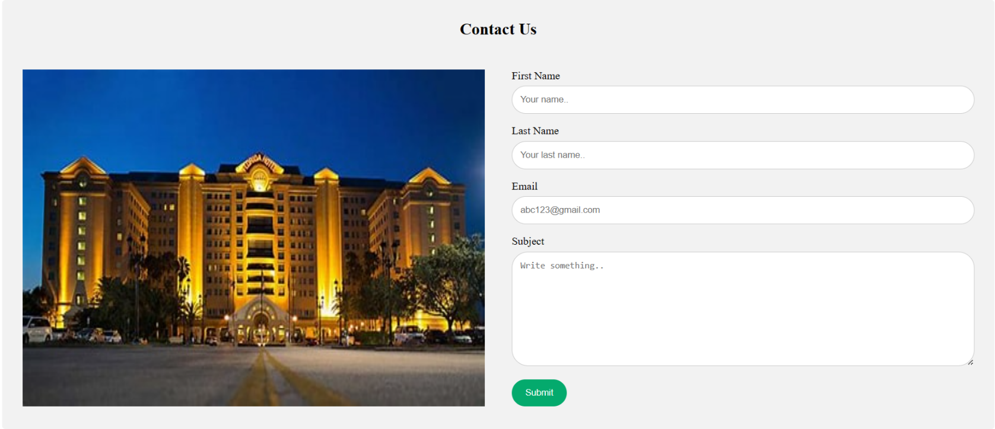

# Fig 12. Footer



# Technologies

##### HTML(Hyper Text Markup Language):-

HTML (Hyper Text Markup Language) is the most basic building block of the Web. It defines the meaning and structure of web content. Other technologies besides HTML are generally used to describe a web page's appearance/presentation (CSS) or functionality/behavior (JavaScript).

##### CSS(Cascading Styling Sheet):-

Cascading Style Sheets (CSS) is a style sheet language used for describing the presentation of a document written in a markup language such as HTML . CSS is a cornerstone technology of the World Wide Web, alongside HTML and JavaScript. CSS is designed to enable the separation of content and presentation, including layout, colors, and fonts.

##### JavaScript :-

JavaScript is a programming language used primarily for creating interactive front-end web applications. It is one of the core technologies used for building modern web applications and is supported by all major web browsers. JavaScript is often used in conjunction with HTML and CSS to create rich, interactive web pages. It is a versatile language that can be used for a variety of purposes, including creating web applications, building mobile applications using frameworks such as React Native and Ionic, and developing server-side applications using Node.js.

### Conclusion

In conclusion, the development and implementation of our Hotel Management Website stand as a pivotal step toward redefining the standards of excellence in the hospitality industry. Through a meticulous project planning phase, we have strategically aligned our goals to optimize operational efficiency, elevate the guest experience, and maximize revenue potential. The innovative features of our platform, from a dynamic reservation system to robust guest relationship management, reflect our commitment to meeting the evolving needs of both hotel administrators and discerning guests.

As we propel into this new era of hospitality, characterized by streamlined processes and personalized services, our focus remains unwavering on delivering a seamless and enjoyable experience for all stakeholders. The integration of advanced technologies not only enhances the day-to-day operations but also establishes a foundation for sustained success and competitiveness in the digital age.

Furthermore, our dedication to data security and compliance underscores our commitment to prioritizing the trust and privacy of our users. By implementing stringent security measures, we ensure that guest information and financial transactions are handled with the utmost care and in compliance with relevant regulations.

In essence, our Hotel Management Website is more than a technological solution; it is a testament to our vision for a hospitality industry that embraces innovation, efficiency, and guest-centricity. We are excited to embark on this journey of transformation, and we believe that our platform will set a new standard for excellence, providing a blueprint for the future of hospitality management. As we move forward, we anticipate the positive impact our platform will have on the industry, ushering in an era where hotels seamlessly blend technology and hospitality to create unparalleled guest experiences.

### Future work

### While the real estate website mini project has provided a solid foundation, there are several avenues for future work and enhancements to further improve the website's functionality and user experience. Some potential areas for future work include:

**Real-Time Booking Availability:** Future work should focus on enhancing the real-time booking availability feature. Implement advanced algorithms and analytics to optimize room inventory management, allowing for more precise real-time updates and dynamic pricing strategies. This includes exploring the integration of machine learning models to predict booking patterns and optimize room allocation for maximum efficiency.

**User Reviews and Ratings:** Enhancements in the user reviews and ratings section should include the implementation of sentiment analysis tools to provide more nuanced insights into guest feedback. Additionally, consider features such as verified reviews and personalized recommendations based on user preferences, contributing to a more transparent and user-centric review system.

**Social Media Integration:** Social media integration represents a key area for future work. Explore deeper integration with popular social platforms to enable seamless sharing of experiences, bookings, and promotions. Leverage social media analytics to gain valuable insights into user behavior and preferences, contributing to targeted marketing strategies and enhanced social engagement.

**Responsive Design Optimization:** Continuous improvement in responsive design is essential for adapting to evolving user preferences and technological advancements. Future work should include regular audits of the website's responsiveness across various devices and browsers, ensuring an optimal user experience regardless of the platform used for access.

**Mobile Application Development:** The development of a dedicated mobile application is a strategic move for future work. This involves creating a user-friendly and feature-rich mobile app that complements the website's functionalities. The application should prioritize a seamless booking process, intuitive navigation, and offline functionality to enhance user convenience.

### Reference

#### Websites

* 1. https://alvarotrigo.com/blog/website-footers/
  2. https://[www.w3schools.com/](http://www.w3schools.com/)

#### GitHub Repository Link

[MuskanVishwakarmaa/Mini-Project-Hotel-Management- (github.com)](https://github.com/MuskanVishwakarmaa/Mini-Project-Hotel-Management-)

**Source Code**

index.html

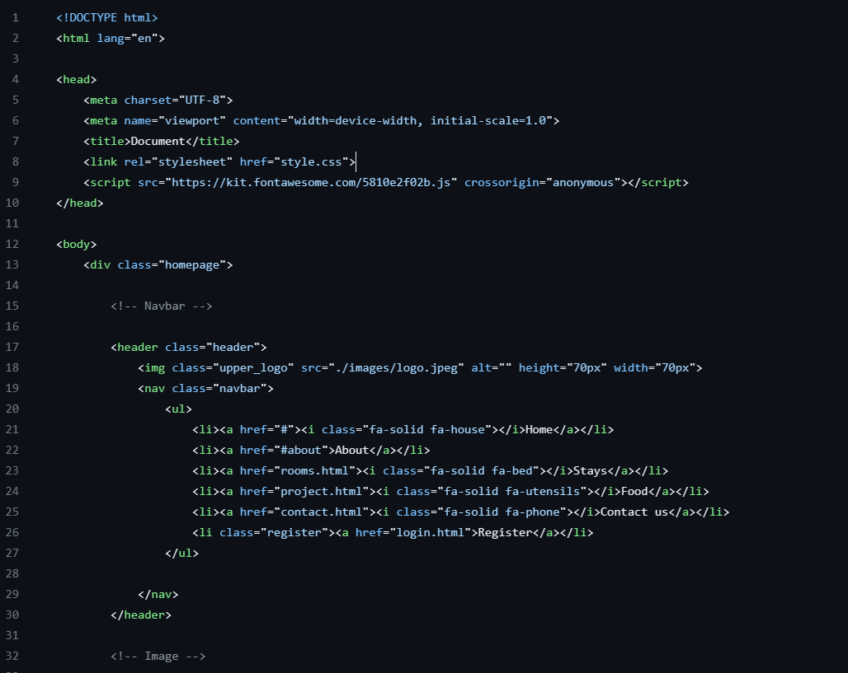

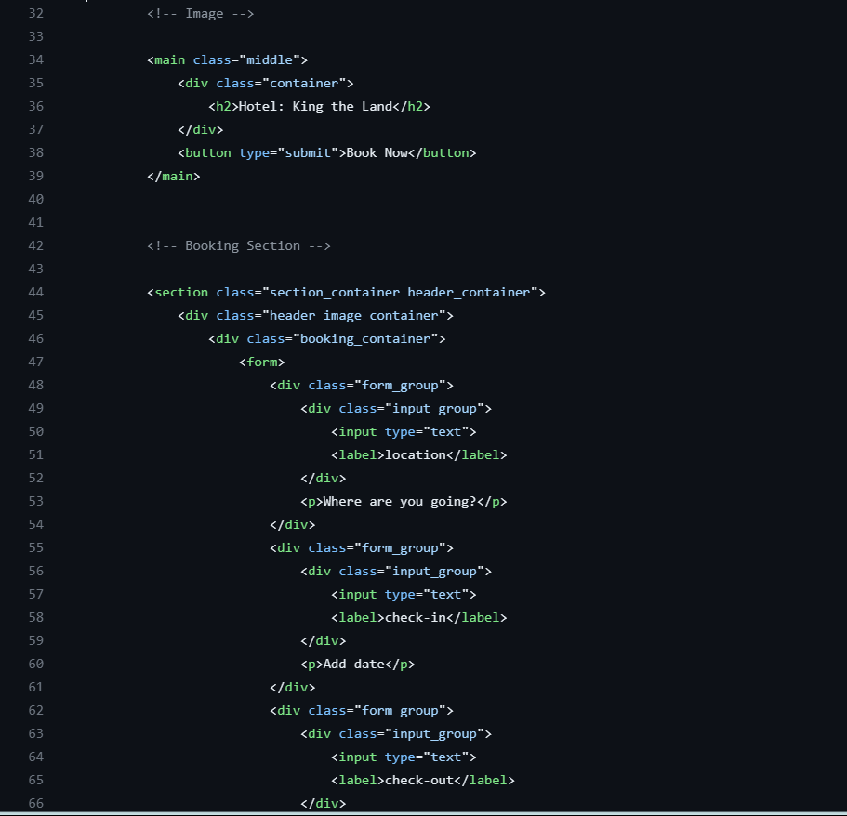

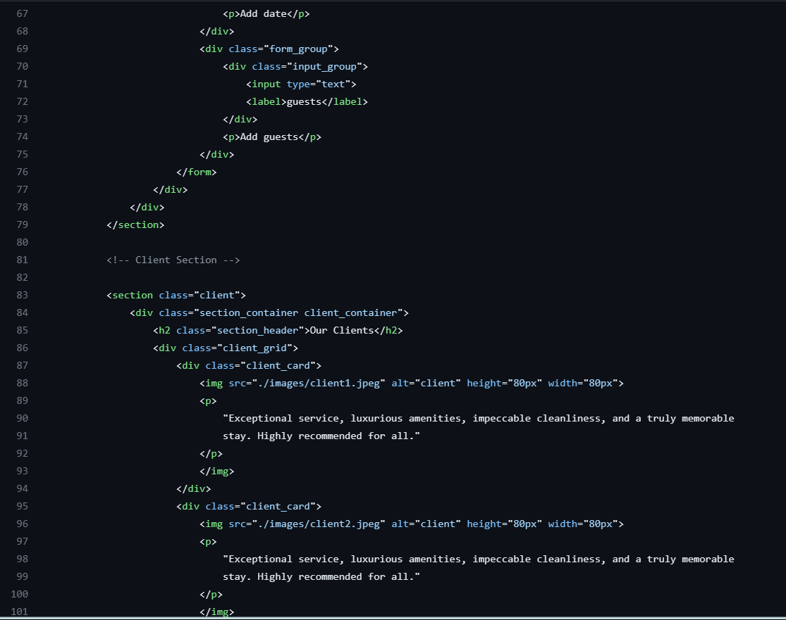

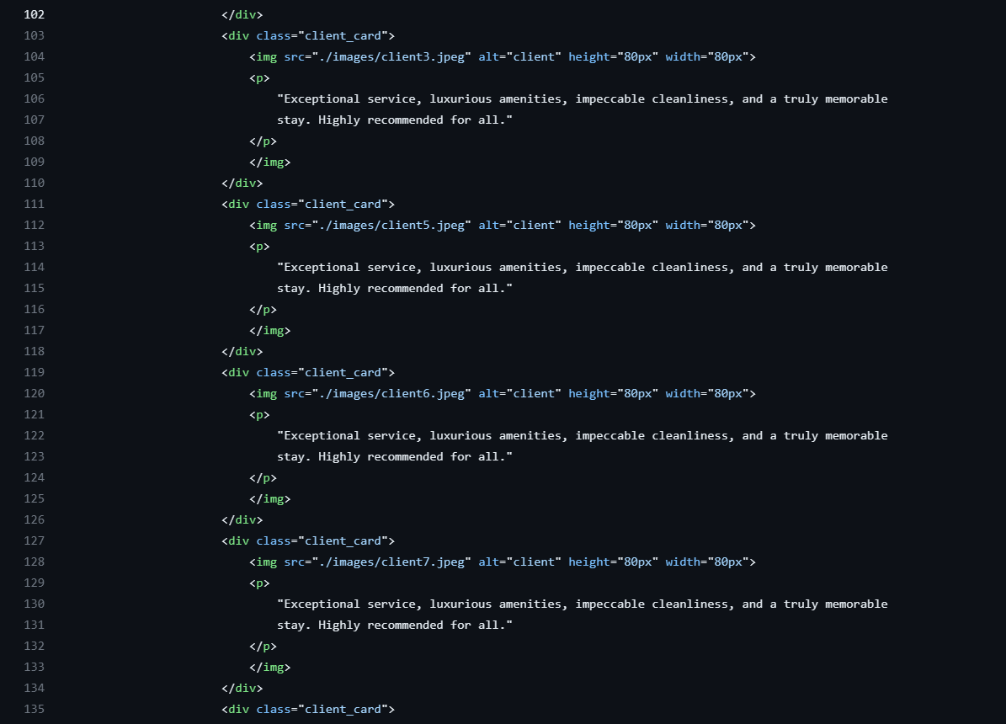

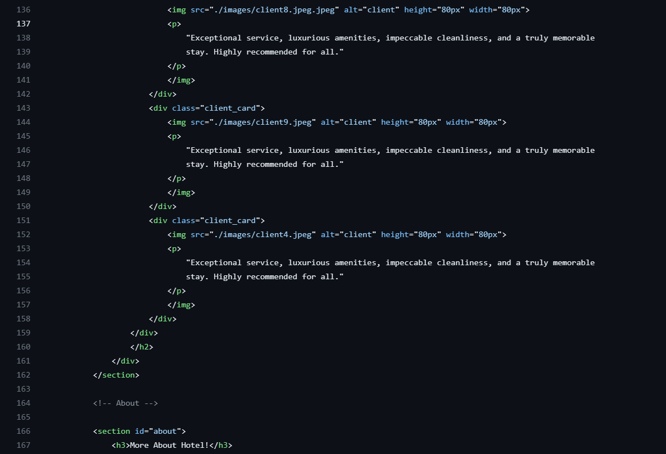

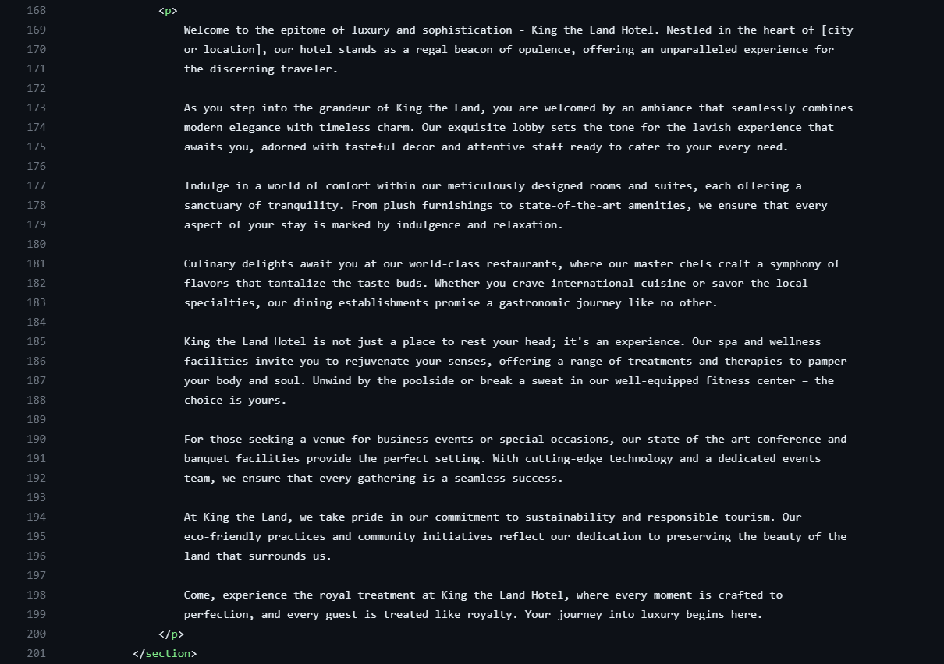

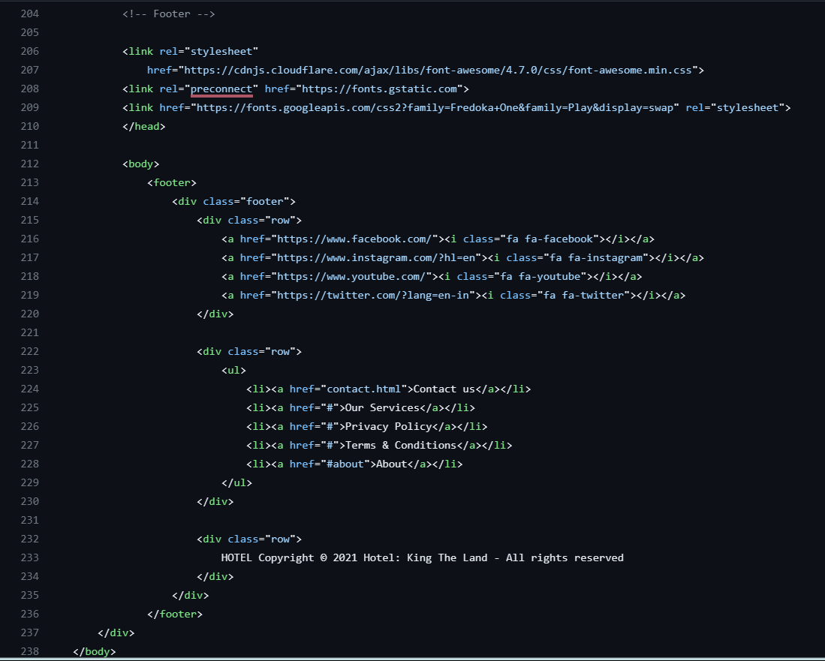

project.html

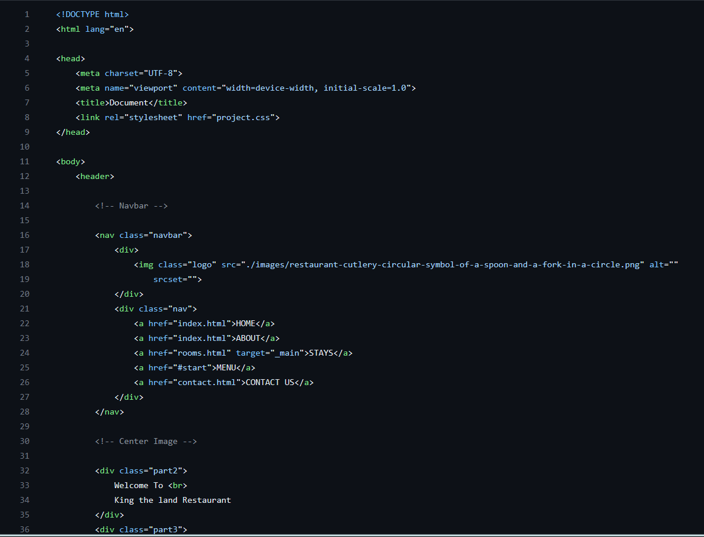

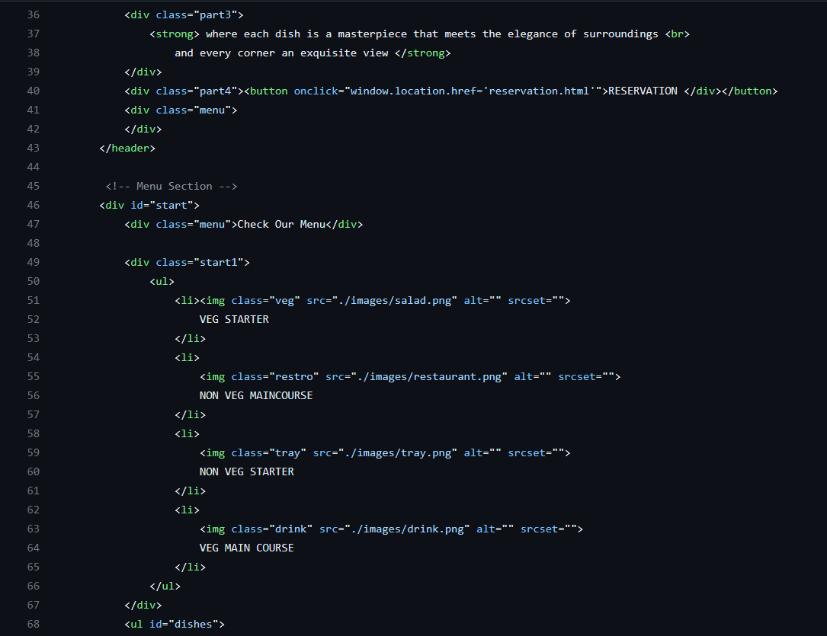

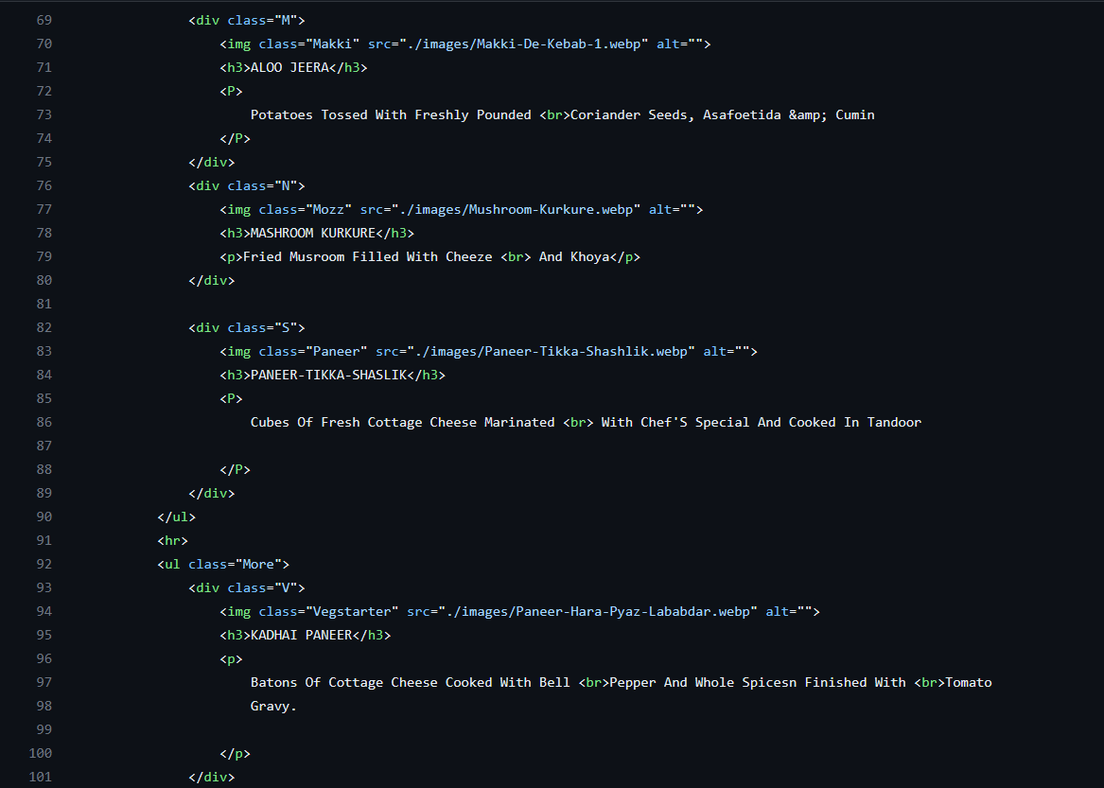

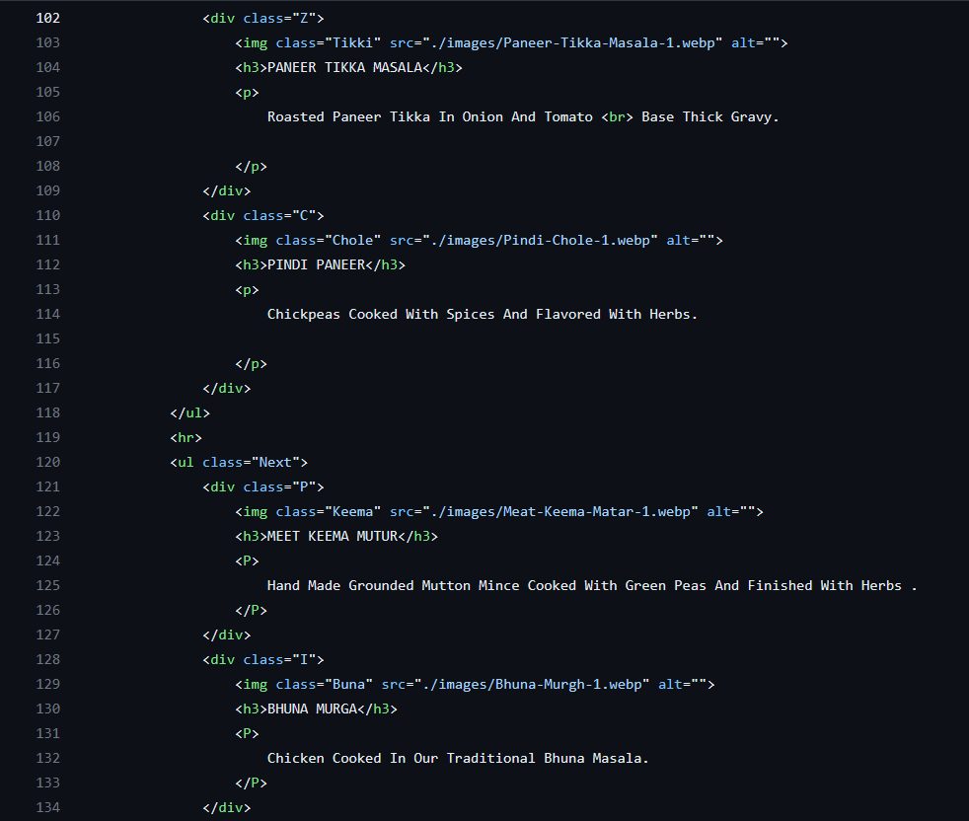

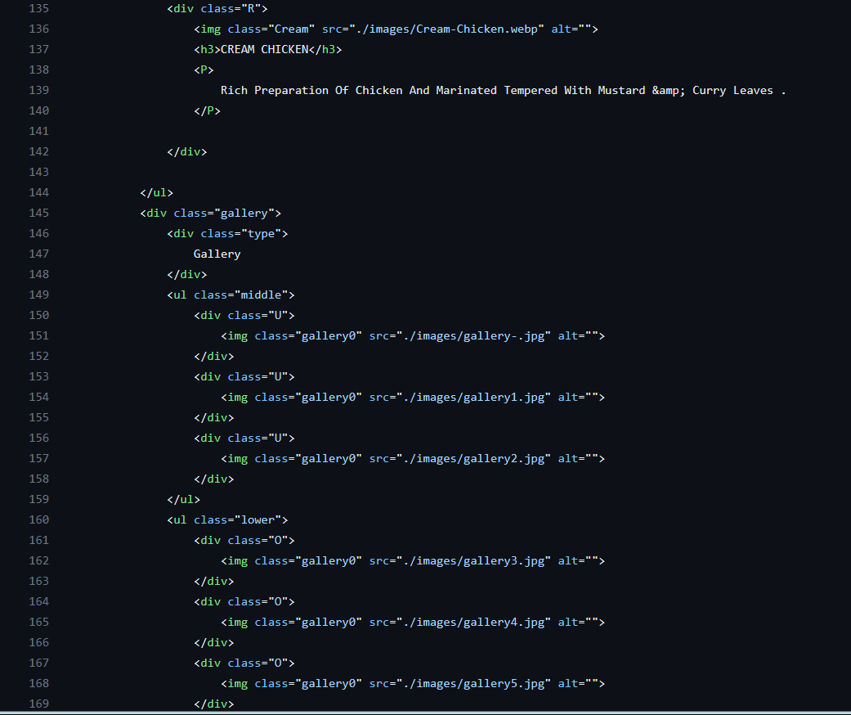

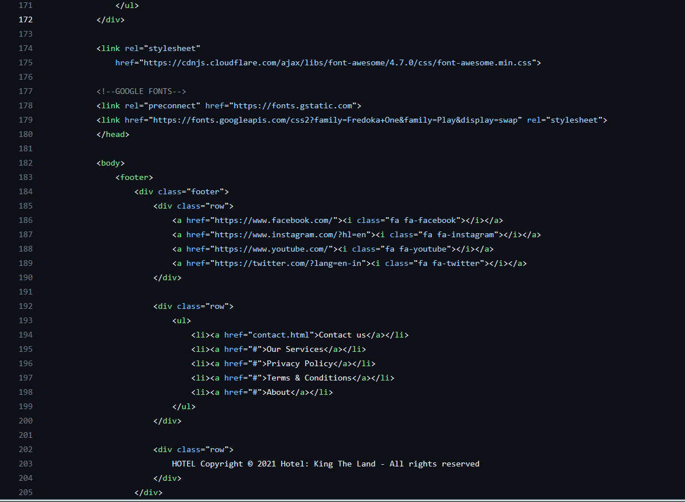

rooms.html

